Exercise 1: Mocking and Stubbing(Mandatory)

Scenario:

You need to test a service that depends on an external API. Use Mockito to mock the

external API and stub its methods.

Steps:

1. Create a mock object for the external API.

package com.example;

public class ExternalApi {

public String getData()

{

  return "Real API Data";

} }

2. Stub the methods to return predefined values.

package com.example;

public class MyService {

    private ExternalApi api;

    public MyService(ExternalApi api) {

        this.api = api;

    }

    public String fetchData() {

        return api.getData();

    }

}

3. Write a test case that uses the mock object.

package com.example;

import org.junit.jupiter.api.Test;

import static org.junit.jupiter.api.Assertions.assertEquals;

import static org.mockito.Mockito.*;

public class MyServiceTest {

    @Test

    public void testExternalApi() {

        ExternalApi mockApi = mock(ExternalApi.class);

        when(mockApi.getData()).thenReturn("Mock Data");

        MyService service = new MyService(mockApi);

        String result = service.fetchData();

        assertEquals("Mock Data", result);

    }

}

**OUTPUT :**

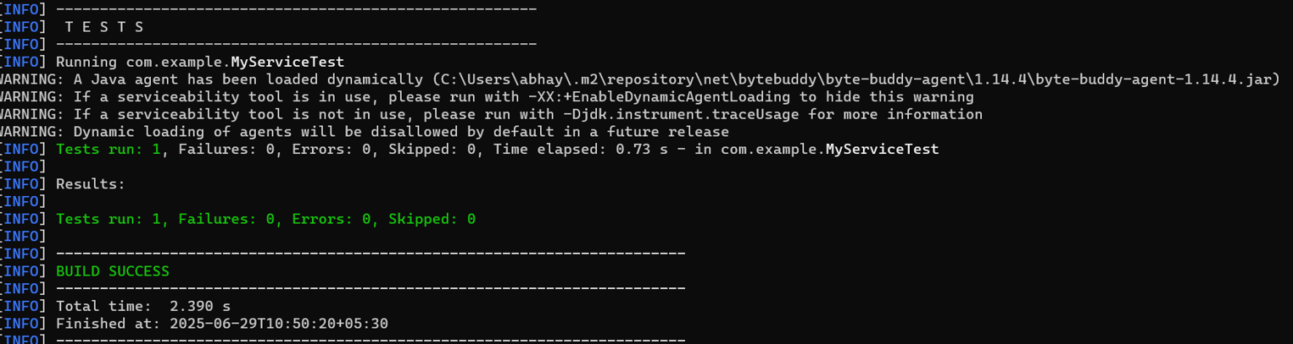

Exercise 2: Verifying Interactions

Scenario:

You need to ensure that a method is called with specific arguments.

**CODE :**

package com.example;

import org.junit.jupiter.api.Test;

import static org.mockito.Mockito.*;

public class MyServiceTest {

    @Test

    public void testVerifyInteraction() {

        ExternalApi mockApi = mock(ExternalApi.class);

        MyService service = new MyService(mockApi);

        service.fetchData();

        verify(mockApi).getData();

    }

}

**Output:**

